**Invention of Molecular Markers Specific and RPA Detection Kit for *Colletotrichum gloeosporioides* in *Dioscorea alata***

XU Weiteng1,2,3†, LU Xinyu1,2,3†, WANG Yue1,2,3, LI Minghan1,2,3, Hu Ke1,2,3, Shen Zijie1,2,3, SUN Xiaoqin1,2,3*, ZHANG Yanmei1,2,3*

1 Institute of Botany, Jiangsu Province and Chinese Academy of Sciences, Nanjing, China, 2 Jiangsu Key Laboratory for the Research and Utilization of Plant Resources, Nanjing, China, 3 Jiangsu Provincial Science and Technology Resources Coordination Platform (Agricultural Germplasm Resources) Germplasm Resources Nursery of Medicinal Plants, Nanjing, China.

**Abstract** The greater yam(*Dioscorea alata*), a widely cultivated and nutritious food crop, suffers from widespread yield reduction due to anthracnose caused by *Colletotrichum gloeosporioides*. Anthracnose is latent in the early stages of plant infection, making early prevention difficult and causing significant harm to agricultural production. This study uses bioinformatics to conduct comparative genomics analysis on 60 species of anthracnose fungi, selecting 17 groups of *C. gloeosporioides*-specific genes. Primers were designed for the more conserved specific gene sequences, and 4 pairs of primers with strong specificity and high sensitivity were finally selected, which can specifically identify *C. gloeosporioides*, with a primer detection sensitivity of 0.1 ng/μL. To further establish a rapid, portable, and operable anthracnose diagnostic method suitable for field use, specific RPA primer probe combinations were designed, and an RPA detection kit for *C. gloeosporioides* was invented, with a sensitivity reaching the picogram (pg) level, successfully establishing a rapid visualization diagnosis method for field yam anthracnose. This study has developed molecular markers for the identification of *C. gloeosporioides* based on specific genes, which can be applied to the prevention and control of yam anthracnose, and also have reference value for the identification and diagnosis of other plant pathogens.

**Keywords** *Dioscorea alata*; *Colletotrichum gloeosporioides*; Primer development; Pathogen identification; Disease diagnosis

# 1 Introduction

*Dioscorea alata*, commonly known as greater yam, is a widely cultivated and highly important crop in tropical and subtropical areas. It is the most widely distributed and the most-produced yam species globally, expect *D. polystachya*[1]. Greater yam is widely cultivated tuber crop for its high yield potential, even in low soil fertility conditions, as well as its ease of propagation, early vigor in competing with weeds, rich in starch and protein [2], and tuber storability[3]. However, the yield of greater yam has been hindered by various biotic and abiotic constraints. Pathogen infection is the main problem affecting greater yam yield and post-harvest quality[4]. Presently, most cultivated varieties of greater yam are landraces. Planting and breeding durable resistant greater yam cultivars are effective ways to control diseases. However, the challenges posed by its reproductive mechanisms and genetic background, leading to breeding programs have struggled with low crossing success[5,6]. Anthracnose is always a major threat to greater yam security, as one of the top 10 plant fungal pathogens[7], causing huge annual economic losses worldwide. China is one of the largest producers and consumers of greater yam in the world, with 1.9 million cultivated hectares[8]. The prevention and control of anthracnose disease is crucial for greater yam production.

*Colletotrichum gloeosporioides* is a widespread and highly adaptable pathogen that is widely accepted as the causal agent of greater yam anthracnose. This fungus is known for its broad host range, infecting over 470 different host genera[9], from monocotyledons to higher dicotyledons. Greater yam anthracnose can induce symptoms such as leaf necrosis, premature shedding, and wilting of young shoots in yam plants, resulting in yield reductions of up to 90%[5], lead to significant economic losses and has necessitated frequent fungicide applications for chemical control. However, this approach poses environmental risks, potential fungicide resistance, and is often cost-prohibitive for many farmers in tropical regions[10]. Moreover，host-plant resistance to *C. gloeosporioides* is the primary focus of yam breeding programs in the tropics. However, recent studies have revealed a high genotypic diversity within *C. gloeosporioides*[11], suggesting the potential for the development of new virulent strains capable of overcoming plant resistance. Controlling *C. gloeosporioides* disease has been hampered by its rapid spread and long-term survival in natural environments. The pathogen exhibits a relatively extended incubation period following its infection of the host plant, thereby impeding the activation of the plant's immune responses. The infection is frequently well established by the time visible symptoms manifest[12]. Therefore, the rapid and accurate detection of *C. gloeosporioides* during the early infection stages is critical for disease management.

Traditionally, the identification and characterization of *Colletotrichum* spp. relied on morphological features such as colony color, conidia and appressorium shape, and growth rate. However, molecular techniques now provide alternative methods for taxonomic studies and are important tools for species delimitation. The selection of appropriate target genes is essential for the successful development of molecular diagnostic assays for plant pathogens. The target genes should exhibit a high degree of conservation within the pathogen species to ensure broad applicability across different strains and isolates. One established conventional PCR-based method for detecting *C. gloeosporioides* is to detect the internally transcribed spacer (ITS) 1 region of ribosomal DNA (rDNA). In addition, Taqman real-time PCR analysis methods targeting mating type gene Mat1-2-1 (ApMat) marker has been established[13]. However, for *Colletotrichum* genera, these regions have a low resolution for species discrimination and diagnosis[14,15]. Due to these limitations of known targets, finding a new specific target using comparative genomics is needed for rapid detection of *C. gloeosporioides*.

Comparative genomics is a powerful approach used to identify specific target genes for various applications, including diagnostics[16], classification[17], and evolutionary[18] studies. By comparing the genomes of different species or individuals within a species, researchers can identify genes that are unique to specific lineages, further to design species-specific diagnostic assays. In the examination of the genus *Colletotrichum*, comparative genomics has been employed to update the classification system[19] and expedite the screening process[20]. OrthoFinder is a highly popular tool in the field of comparative genomics, known for its ability to easily identify orthologous groups[21]. These groups, which consist solely of the complete gene sets of the *Colletotrichum gloeosporioides* species, are considered to be species-specific. The essential innovation of our study is the application of this approach to find target sequences beyond commonly identified fragments. Compared to conventional methods, OrthoFinder is not confined to developing molecular markers for known sequences alone but encompassing the entire genome[22]. This approach effectively avoids the potential oversight of unknown or variant target sequences, thereby enhancing the specificity and breadth of the applicability of the primers. Molecular techniques, including PCR and quantitative real-time PCR (qRT-PCR) are highly sensitive DNA-based methods that have been successfully applied to detect *C. gloeosporioides* in a wide range of crops, including fruit[23], vegetables[24], and herbs. These approaches have provided a rapid and sensitive means of detecting and quantifying *C. gloeosporioides*. However, PCR-based methods are not suitable for on-site field detection due to the need for bulky and expensive lab equipment and complicated protocols for both DNA extraction and amplification. Recombinase Polymerase Amplification (RPA) has emerged as a promising alternative to traditional PCR-based methods for the detection of plant pathogens. Unlike PCR, RPA does not require temperature cycling conditions, making it more conducive for field applications. This isothermal amplification technique offers several advantages, including field mobility, rapid results, and the ability to perform amplification directly on sample material without the need for DNA extraction[25]. Furthermore, the combination of RPA with lateral flow assays (LFA) allows for rapid and visual detection of results, enhancing its practicality for on-site testing.

This study aims to employ comparative genomics to identify specific genes in *C. gloeosporioides*, addressing the challenges associated with the specific identification of the organism and rapid field diagnosis. We identified novel molecular markers and developed a rapid and simple lateral flow (LF)-RPA assay for the detection of *C. gloeosporioides* by targeting these specific target genes of *C. gloeosporioides*. We screened out optimal species-specific and sensitivity of primers and compared the detection results with those of traditional PCR using 1000-fold serial dilution of *C. gloeosporioides* genomic DNA and crude extracts from infected greater yam as templates. The LF-RPA assay enabled the rapid and simple detection of *C. gloeosporioides* in resource-limited laboratories and have the potential to enhance agricultural production. Furthermore, this study presents novel methods for the identification and molecular mark development of plant pathogens, with potential applications in the investigation and control of various plant pathogens.

# 2 Materials and Methods

## 2.1 Materials

In the study, 60 strains representing 38 species from the genus *Colletotrichum* were sequenced, with a particular focus on the *Colletotrichum gloeosporioides* strain CgDa01 (GCA_021650765.1), which was recently isolated from the greater yam host[26]. Additionally, 59 *Colletotrichum* genomes and 2 outgroup genomes were downloaded from NCBI database and analyzed (Table 1). The mean genome size for the investigated *Colletotrichum* species was calculated to be 57.02 Mbp. The plant specimens collected from experimental materials were deposited in Institute of Botany, Jiangsu Province and Chinese Academy of Sciences (NAS).

**Table 1 Sequence information of the genes involved in the experiment**

|  |  |  |  |  |  |
| --- | --- | --- | --- | --- | --- |
| **No.** | **Specie** | **NCBI ID** | **Strain** | **Size (Mbp)** | |
| 1 | *Colletotrichum gloeosporioides* | GCA_021432615.1 | 23 | | 58.84 |
| 2 | *Colletotrichum gloeosporioides* | GCA_000446055.1 | Cg-14 | | 53.21 |
| 3 | *Colletotrichum gloeosporioides* | GCA_011800055.1 | Lc1 | | 61.90 |
| 4 | *Colletotrichum gloeosporioides* | GCA_021650765.1 | CgDa01 | | 62.78 |
| 5 | *Colletotrichum chlorophyti* | GCA_001937105.1 | NTL11 | | 52.39 |
| 6 | *Colletotrichum filicis* | GCA_023376865.1 | CBS 101611 | | 62.97 |
| 7 | *Colletotrichum fioriniae* | GCA_000582985.1 | PJ7 | | 49.00 |
| 8 | *Colletotrichum fructicola* | GCA_009771025.1 | CGMCC3.17371 | | 58.06 |
| 9 | *Colletotrichum fructicola* | GCA_012932255.1 | Cg38 S1 | | 58.95 |
| 10 | *Colletotrichum fructicola* | GCA_013201875.1 | CfS4 | | 57.43 |
| 11 | *Colletotrichum fructicola* | GCA_013201905.1 | Cf415 | | 56.01 |
| 12 | *Colletotrichum fructicola* | GCA_013201925.1 | Cf245 | | 56.06 |
| 13 | *Colletotrichum fructicola* | GCA_013390205.1 | Cf413 | | 56.53 |
| 14 | *Colletotrichum fructicola* | GCA_000319635.1 | Nara gc5 | | 55.61 |
| 15 | *Colletotrichum fructicola* | GCA_000319635.2 | Nara gc5 | | 59.54 |
| 16 | *Colletotrichum abscissum* | GCA_023376855.1 | Ca142 | | 54.00 |
| 17 | *Colletotrichum aenigma* | GCA_013390185.1 | Cg56 | | 59.19 |
| 18 | *Colletotrichum asianum* | GCA_009806415.1 | ICMP 18580 | | 64.73 |
| 19 | *Colletotrichum camelliae* | GCA_011947485.2 | CcLH18 | | 57.80 |
| 20 | *Colletotrichum graminicola* | GCA_000149035.1 | M1.001 | | 51.60 |
| 21 | *Colletotrichum higginsianum* | GCA_000313795.2 | IMI 349063 | | 49.08 |
| 22 | *Colletotrichum higginsianum* | GCA_004920355.1 | MAFF30563 | | 49.79 |
| 23 | *Colletotrichum higginsianum* | GCA_023705605.1 | MAFF 245053 | | 49.07 |
| 24 | *Colletotrichum higginsianum* | GCA_001672515.1 | IMI 349063 | | 50.72 |
| 25 | *Colletotrichum incanum* | GCA_001625285.1 | MAFF 238704 | | 53.60 |
| 26 | *Colletotrichum incanum* | GCA_001855235.1 | MAFF238712 | | 53.25 |
| 27 | *Colletotrichum karsti* | GCA_011947395.2 | CkLH20 | | 51.85 |
| 28 | *Colletotrichum liriopes* | GCA_022179045.1 | MAFF 242679 | | 52.97 |
| 29 | *Colletotrichum lupini* | GCA_023278565.1 | IMI 504893 | | 63.41 |
| 30 | *Colletotrichum musicola* | GCA_014235935.1 | LFN0074 | | 52.73 |
| 31 | *Colletotrichum nymphaeae* | GCA_001563115.1 | SA-01 | | 49.96 |
| 32 | *Colletotrichum orbiculare* | GCA_000350065.2 | 104-T | | 89.75 |
| 33 | *Colletotrichum orchidophilum* | GCA_001831195.1 | IMI 309357 | | 48.56 |
| 34 | *Colletotrichum plurivorum* | GCA_014235945.1 | LFN00145 | | 49.70 |
| 35 | *Colletotrichum salicis* | GCA_001563125.1 | CBS 607.94 | | 48.37 |
| 36 | *Colletotrichum scovillei* | GCA_011075155.1 | TJNH1 | | 52.00 |
| 37 | *Colletotrichum scovillei* | GCA_018906675.1 | Coll-365 | | 49.92 |
| 38 | *Colletotrichum scovillei* | GCA_018906765.1 | Coll-153 | | 50.11 |
| 39 | *Colletotrichum scovillei* | GCA_018907675.1 | Coll-524 | | 51.49 |
| 40 | *Colletotrichum shisoi* | GCA_006783085.1 | PG-2018a | | 69.67 |
| 41 | *Colletotrichum siamense* | GCA_013201745.1 | CAD2 | | 58.15 |
| 42 | *Colletotrichum siamense* | GCA_013201755.1 | CAD5 | | 58.40 |
| 43 | *Colletotrichum siamense* | GCA_013201795.1 | CAD4 | | 58.15 |
| 44 | *Colletotrichum siamense* | GCA_013201865.1 | CAD1 | | 58.40 |
| 45 | *Colletotrichum siamense* | GCA_013390195.1 | Cg363 | | 62.94 |
| 46 | *Colletotrichum sidae* | GCA_004367935.1 | CBS 518.97 | | 86.83 |
| 47 | *Colletotrichum simmondsii* | GCA_001563135.1 | CBS122122 | | 50.47 |
| 48 | *Colletotrichum sojae* | GCA_014235955.1 | LFN0009 | | 49.35 |
| 49 | *Colletotrichum spaethianum* | GCA_022836535.1 | MAFF 239500 | | 50.92 |
| 50 | *Colletotrichum spinosum* | GCA_004366825.1 | CBS 515.97 | | 82.73 |
| 51 | *Colletotrichum sublineola* | GCA_000696135.1 | TX430BB | | 46.76 |
| 52 | *Colletotrichum tanaceti* | GCA_005350895.1 | BRIP57314 | | 57.91 |
| 53 | *Colletotrichum tofieldiae* | GCA_001625265.1 | 0861 | | 52.84 |
| 54 | *Colletotrichum tofieldiae* | GCA_022836555.1 | MAFF 712333 | | 54.25 |
| 55 | *Colletotrichum tofieldiae* | GCA_022836575.1 | MAFF 712334 | | 53.98 |
| 56 | *Colletotrichum tofieldiae* | GCA_022836595.1 | 0861 | | 52.99 |
| 57 | *Colletotrichum trifolii* | GCA_004367215.1 | 543-2 | | 109.7 |
| 58 | *Colletotrichum tropicale* | GCA_013201785.1 | CgS9275 | | 55.85 |
| 59 | *Colletotrichum truncatum* | GCA_014235925.1 | CMES1059 | | 56.10 |
| 60 | *Colletotrichum viniferum* | GCA_013201765.1 | CGW01 | | 68.45 |
| 61 | *Sodiomyces alkalinus* | GCA_003711515.1 | F11 | | 43.5 |
| 62 | *Verticillium dahliae* | GCA_000150675.2 | VdLs.17 | | 33.8 |

The fungal species included in this research comprised *Fusarium graminearum*, *Fusarium oxysporum*, *Sclerotinia sclerotiorum*, *Botrytis cinerea*, *Blumeria graminis*, *Colletotrichum fructicola*, and specifically, the *C. gloeosporioides* strain CgDa01 and CgDaM3. Our team successfully isolated and propagated the CgDa01 and CgDaM3 strain in our laboratory. The *Colletotrichum fructicola* strain gifted by the Fruit Tree Research Centre, NAS. Additionally, Dou's laboratory at Nanjing Agricultural University provided the other strains.

## 2.2 Comparative Genomic Analysis

OrthoFinder software (version 2.5.2) was employed to analyze orthologous relationships across all coding genes found within *Colletotrichum*[27]. The analysis involved utilizing complete proteome sequences from 60 different *Colletotrichum* fungi, with the default settings of the software recommended. Genes identified exclusive to all the *Colletotrichum gloeosporioides* strains—absent in the genomes of other *Colletotrichum* species—were categorized as unique to *C. gloeosporioides*. We then performed ClustalW multiple alignment comparison using BioEdit (v7.2.5)[28] software with default parameters to manually screen for conserved fragments in each immediate homologous group. Sequences present in all *C. gloeosporioides* genomes were selected through the NCBI web interface[29]. They were used for the next step of molecular marker design.

## 2.3 Fungal Cultivation and Genomic DNA Extraction

The fungi were cultivated on Potato Dextrose Agar (PDA) medium and incubated at 28°C for 5 days. Mycelium from the actively growing margin of the culture was carefully transferred to fresh plates to establish pure, isolated colonies by incubating under the same conditions. From these colonies, mycelium was introduced into Potato Dextrose Broth (PDB) medium and incubated for 2 days. After the incubation period, the culture was filtered, and the mycelium was collected, promptly frozen in liquid nitrogen, and ground to a fine powder. The genomic DNA was then extracted from the powdery mycelium using the modified CTAB method[30].

The detailed steps of the extraction process were as follows: (1) Approximately 0.3 g of plant or fungal tissue was placed in a 2 mL centrifuge tube containing 2 sterile steel beads. The contents were frozen in liquid nitrogen and then ground using a ball mill; (2) To the powdered tissue, 800 μL of CTAB extraction buffer (with 2% CTAB, 100 mmol/L Tris-HCl at pH 8.0, 20 mmol/L EDTA, 1.4 mol/L NaCl, and 2% β-mercaptoethanol) was added, and the suspension was incubated at 65°C for 1 hour, inverted every 15 minutes for thorough mixing; (3) Following incubation, 800 μL of phenol:chloroform:isoamyl alcohol (25:24:1) was added, the tube was inverted for mixing, and then centrifuged at 12,000 rpm for 10 minutes, after which the aqueous phase was transferred to a new 2 mL centrifuge tube; (4) An equal volume of chloroform:isoamyl alcohol (24:1) was added, mixed by inversion, centrifuged at 12,000 rpm for 10 minutes, and the aqueous phase was again transferred, this time to a new 1.5 mL centrifuge tube; (5) To this, 0.6 volumes of isopropanol were added, and the mixture was incubated at -20°C for at least 30 minutes for DNA precipitation; (6) The precipitated DNA was pelleted by centrifugation at 12,000 rpm for 10 minutes, the supernatant was discarded, and the DNA pellet was washed twice with 75% ethanol. Thereafter, the DNA pellet was dried in a vacuum dryer for about 40 minutes before being dissolved in water. The DNA concentration was quantified using a spectrophotometer, and the DNA was stored at -20°C for later use.

## 2.4 Primer Design and Specificity Identification

Primers were designed to correspond with the specific gene sequences identified in section 1.2, focusing on the conserved regions within nine of these sequences, utilizing the Primer Premier 5.0[31] software for assistance. To evaluate the specificity of the designed primers, polymerase chain reaction (PCR) assays were performed. The total reaction volume for each PCR was 20 μL, which comprised the following: 10 μL of Taq Green Mix (sourced from Vazyme Biotechnology Co., Ltd.), 0.5 μL of each forward and reverse primer (concentration of 10 μM), 1 μL of the template DNA (concentration at 100 ng/μL), and 8 μL of ddH2O. The PCR conditions included an initial denaturation step at 95°C for 5 minutes, followed by 35 cycles, each cycle consisting of denaturation at 95°C for 15 seconds, annealing at 58°C for 15 seconds, and extension at 72°C for 30 seconds. A final extension was carried out at 72°C for 10 minutes. The resultant PCR products were then subjected to analysis via 1% agarose gel electrophoresis. Primers that demonstrated specific affinity for targeting *Colletotrichum gloeosporioides* were selected for further study.

**Table 2 Candidate gene primer sequences**

|  |  |
| --- | --- |
| **Primer name** | **Primer sequence (5'-3')** |
| Cg-OG0029335-F1 | CTCACGACCGGAACAAGTCT |
| Cg-OG0029335-R1 | GTATGGTTTCATTGCGCGGC |
| Cg-OG0031698-F1 | CGTCAGCTTGTCCTCTGGTA |
| Cg-OG0031698-R1 | GGGTTGTGAACGTCAGTGTG |
| Cg-OG0034809-F1 | GTTTCCAGAGATCGCACCGA |
| Cg-OG0034809-R1 | GCGACAGCTGCTGAAAACTT |
| Cg-OG0034811-F2 | CTGAACTTGCACTGCAGCAA |
| Cg-OG0034811-R2 | CCACACGATGCACCTCTGTT |
| Cg-OG0034812-F1 | ATGGCGGTTGCCACAAATC |
| Cg-OG0034812-R1 | CCTCGAAGTTGTCAGAGCGAT |
| Cg-OG0034817-F2 | CGTTCGTTGCAGAGCCTAAC |
| Cg-OG0034817-R2 | GCAGCATTCACCGCAAGTTT |
| Cg-OG0034823-F1 | TGGAAACGGGAACTTGGTCAG |
| Cg-OG0034823-R1 | CCGTCGTGCAAACCAACAG |
| Cg-OG0034836-F1 | GTTCTGATTGGCGATGCGAC |
| Cg-OG0034836-R1 | TGCGTCATTGACCGTACGAC |
| Cg-OG0034840-F1 | AGGCAGCTTAGCAATCCGAA |
| Cg-OG0034840-R1 | CGGAGAATCTCTGCAAGGGG |

## 2.5 Sensitivity Testing of Primers

For the sensitivity assessment, DNA extracted from the *Colletotrichum gloeosporioides* strain CgDa01 was used as the template. Its concentration was determined with a UV spectrophotometer. A series of serial dilutions was performed to obtain DNA concentrations of 10 ng/μL, 1 ng/μL, 0.1 ng/μL, and down to 10-5 ng/μL. The primers that were specifically designed for *Colletotrichum gloeosporioides*, as described in section 1.4, were then utilized for PCR amplification. The conditions for the amplification were kept consistent with those previously outlined. Following PCR, the amplification products were analyzed by 1% agarose gel electrophoresis.

## 2.6 Inoculation and Detection of Samples Affected by Yam Anthracnose

The practicality of the rapid diagnostic method was evaluated using artificially inoculated greater yam leaves with *Colletotrichum gloeosporioides*, along with field samples of healthy yam leaves. The inoculation protocol[32] involved harvesting conidia from 7-day-old strain CgDa01 cultures. For this, 3 mL of sterile water was added to a 60 mm Petri dish, and the mycelium surface was gently scraped until detached with the aid of a spreader. The resulting slurry was filtered through four layers of gauze into a centrifuge tube, repeating the process as necessary to ensure comprehensive capture of conidia. The conidial concentration was quantified using a hemocytometer and adjusted to 105 conidia/mL with sterile water. Tween-20, at a final concentration of 0.1%, was added to the suspension as an emulsifying agent. Subsequently, the leaves of greater yam were disinfected with alcohol, punctured with a syringe, and inoculated with 10 µL of the conidial emulsion at the puncture site. These leaves were then maintained in a humidified environment inside plastic containers padded with moist cotton and incubated at 25°C for five days. Tissue samples from the lesion peripheries were collected on days 1, 3, and 5 post-inoculations for DNA extraction using the CTAB method and subsequent PCR analysis. For comparison, the control group was inoculated with sterile water alone.

## 2.7 Development of a Rapid RPA Detection Kit

For RPA detection, the Twist Amp nfo kit, manufactured by Twist Amp, was employed. Primers and probes were designed following the recommendations provided in the kit's manual and using Primer Premier 5.0 software for guidance. To prepare for RPA-based rapid detection, DNA was serially diluted to a final concentration of 1 fg/μL. The RPA reaction was configured in a 50 μL mixture containing 2.1 μL of both forward and reverse primers at a concentration of 10 μM, 0.6 μL of the Twist Amp LF probe also at 10 μM concentration, 29.5 μL of the provided buffer, 5 μL of the target DNA, 8.2 μL of deionized distilled water (ddH2O), and finally, 2.5 μL of magnesium acetate at a concentration of 280 mM. After thoroughly mixing the components, the mixture was incubated at 37°C for 4 minutes, per kit guidelines. Following another round of mixing, the sample was incubated again at 37°C for an additional 20 minutes. Detection was then executed using lateral flow chromatography strips. Specifically, 0.5 mL of the reaction mixture was applied onto the sample well of the colloidal gold-labeled immunostrip and allowed to react at ambient temperature for 10 minutes before assessing the results.

# 3.Results and Analysis

## 3.1 Orthologous Gene Clustering and Template DNA screening in the *C. gloeosporioides*

An orthologous gene analysis was carried out on the genomes of 62 species as part of our investigation. included 60 genomes from the *Colletotrichum* spp. and 4 genomes specific to *Colletotrichum gloeosporioides*. Different strains of *C. gloeosporioides* have intraspecific homologous genes ranging from 14,000 to 17,000. 19,050 clusters included at least one gene from them. 12,504 groups were present across all four such genes. The ratio between the two, or Jaccard index[33], is 0.656 (Figure 1A), which indicates the similarity between two gene sets. Furthermore, the analysis resulted in the identification of 59,387 non-redundant orthologous gene families, which accounted for 95.9% of the genes analyzed. Among them, 17 are comprised exclusively of genes from the four studied strains only (Figure 1B). However, a subset of 36,233 genes did not align with any known orthologous clusters. Significantly, the sequence lengths of these orthogroups vary widely, but 14 of them are single-copy (Figure 1C). By aligning the sequences of these groups, we were able to identify conserved domains within each orthologous group. Further screening using BLAST tool at NCBI revealed 9 sequences that were conserved across the remaining *C. gloeosporioides* genomes. They were then designated as templated DNA sequences for next study.

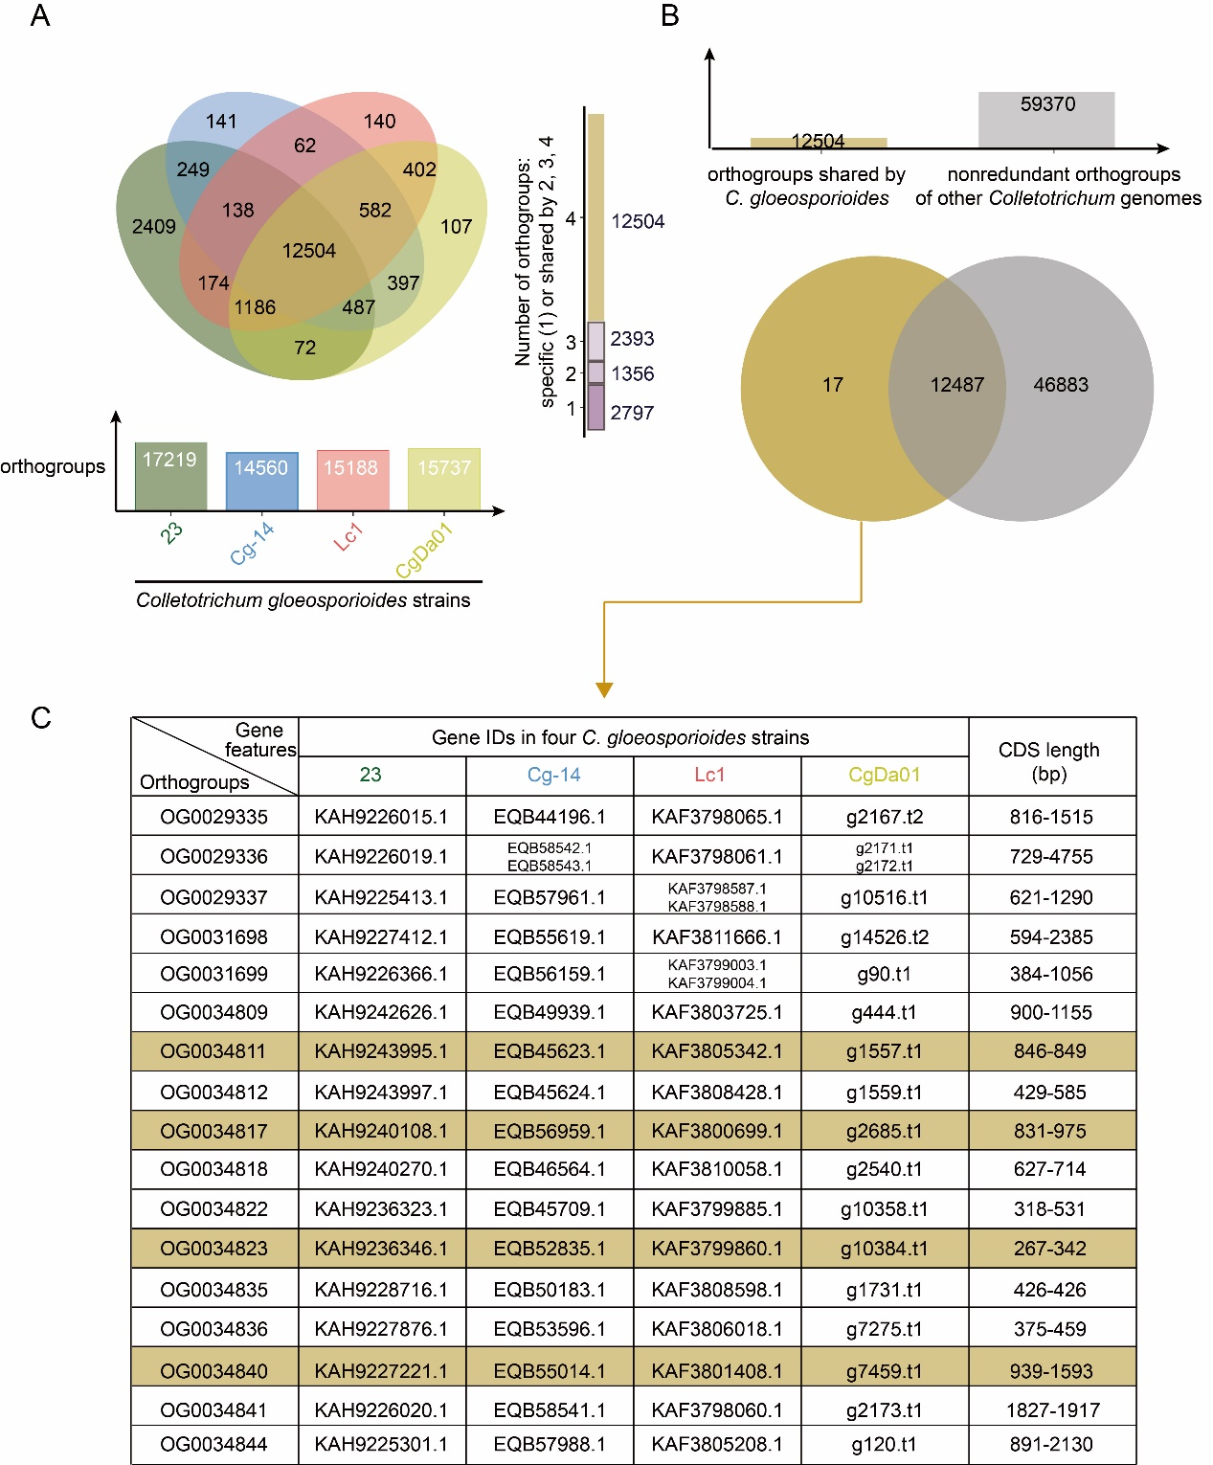

**Figure 1 Statistics of orthologous gene clustering analyses. (A)** Number of orthogroups containing genes from different *C. gloeosporioides* strains，Venn diagram shows the number of orthogroups which are specific (1) or shared by 2,3,4 strains. **(B)** Comparison of orthogroups containing *C. gloeosporioides* strains with all non-redundant orthogroups. **(C)** Details of *C. gloeosporioides*-specific orthogroups, including gene IDs and length, the colored four were eventually used to design molecular markers.

## 3.2 Screening of Specific Primers for *Colletotrichum* *gloeosporioides*

We designed RPA primer pairs based on specific regions of nine molecular markers gene of *C. gloeosporioides,* respectively. Initially, we performed a conventional PCR assay using genomic DNA from 8 isolates as templates, including 2 *C. gloeosporioides* isolates and 2 isolates from *Fusarium* species, 1 *Sclerotinia* species,1 *Botrytis* species, 1 *Blumeria* species, and 1 *Colletotrichum* closely related species. The target products of the primer pairs Cg-OG0034840-F1/R1, Cg-OG0034823-F1/R1, Cg-OG0034817-F2/R2, and Cg-OG0034811-F2/R2 were clearly observed in only the 2 *C. gloeosporioides* isolates; no amplification bands were visualized in the other fungal isolates (Figure 2). Other five primer pairs exhibited non-specific amplification, which were considered unsuitable for targeted detection. The results revealed that the Cg-OG0034840-F1/R1, Cg-OG0034823-F1/R1, Cg-OG0034817-F2/R2, and Cg-OG0034811-F2/R2 primers were highly specific for *C. gloeosporioides*.

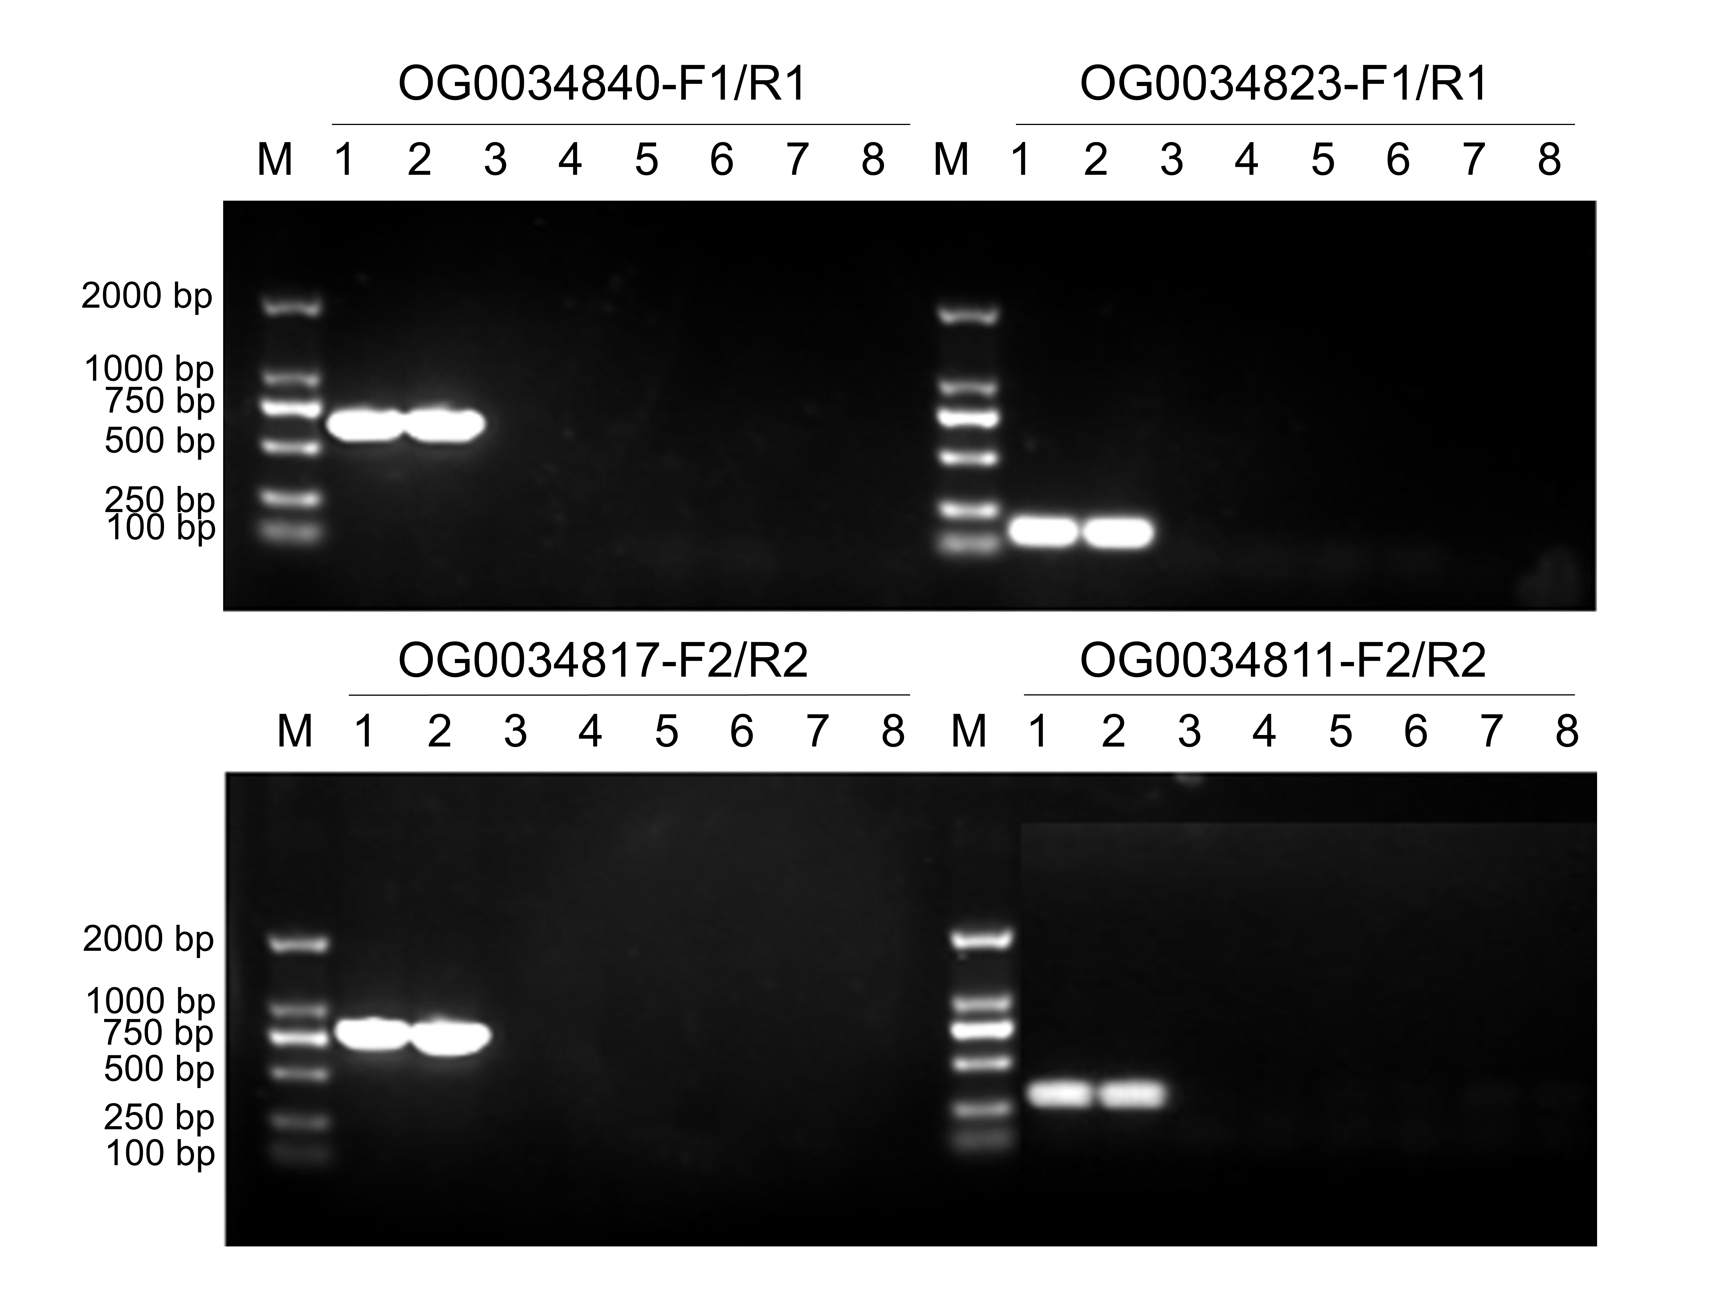

**Figure 2 Determination of the optimal primers for conventional polymerase chain reaction (PCR).** M: 2, 000 bp DNA Ladder; 1: *Colletotrichum gloeosporioides* strain CgDa01; 2: *Colletotrichum gloeosporioides* strain CgDaM3; 3: *Fusarium graminearum*; 4: F*usarium oxysporum*; 5: *Sclerotinia sclerotiorum*; 6: *Botrytis cinerea*; 7: *Blumeria graminis*; 8: *Colletotrichum fructicola*.

## 3.3 Sensitivity Testing of Species-Specific Primers

For further sensitivity evaluation of the Cg-OG0034840-F1/R1, Cg-OG0034823-F1/R1, Cg-OG0034817-F2/R2, and Cg-OG0034811-F2/R2 primers using conventional PCR, reactions were performed using *C. gloeosporioides* genomic DNA as a template to evaluate these primer pairs based on sensitivity tests. The detection limit for Cg-OG0034840-F1/R1 and Cg-OG0034823-F1/R1 was 10 pg, which was more sensitive than that for Cg-OG0034817-F2/R2 and Cg-OG0034811-F2/R2 (Figure 3). The results indicated Cg-OG0034840-F1/R1 and Cg-OG0034823-F1/R1 have high sensitivity and potential for rapid detection methods.

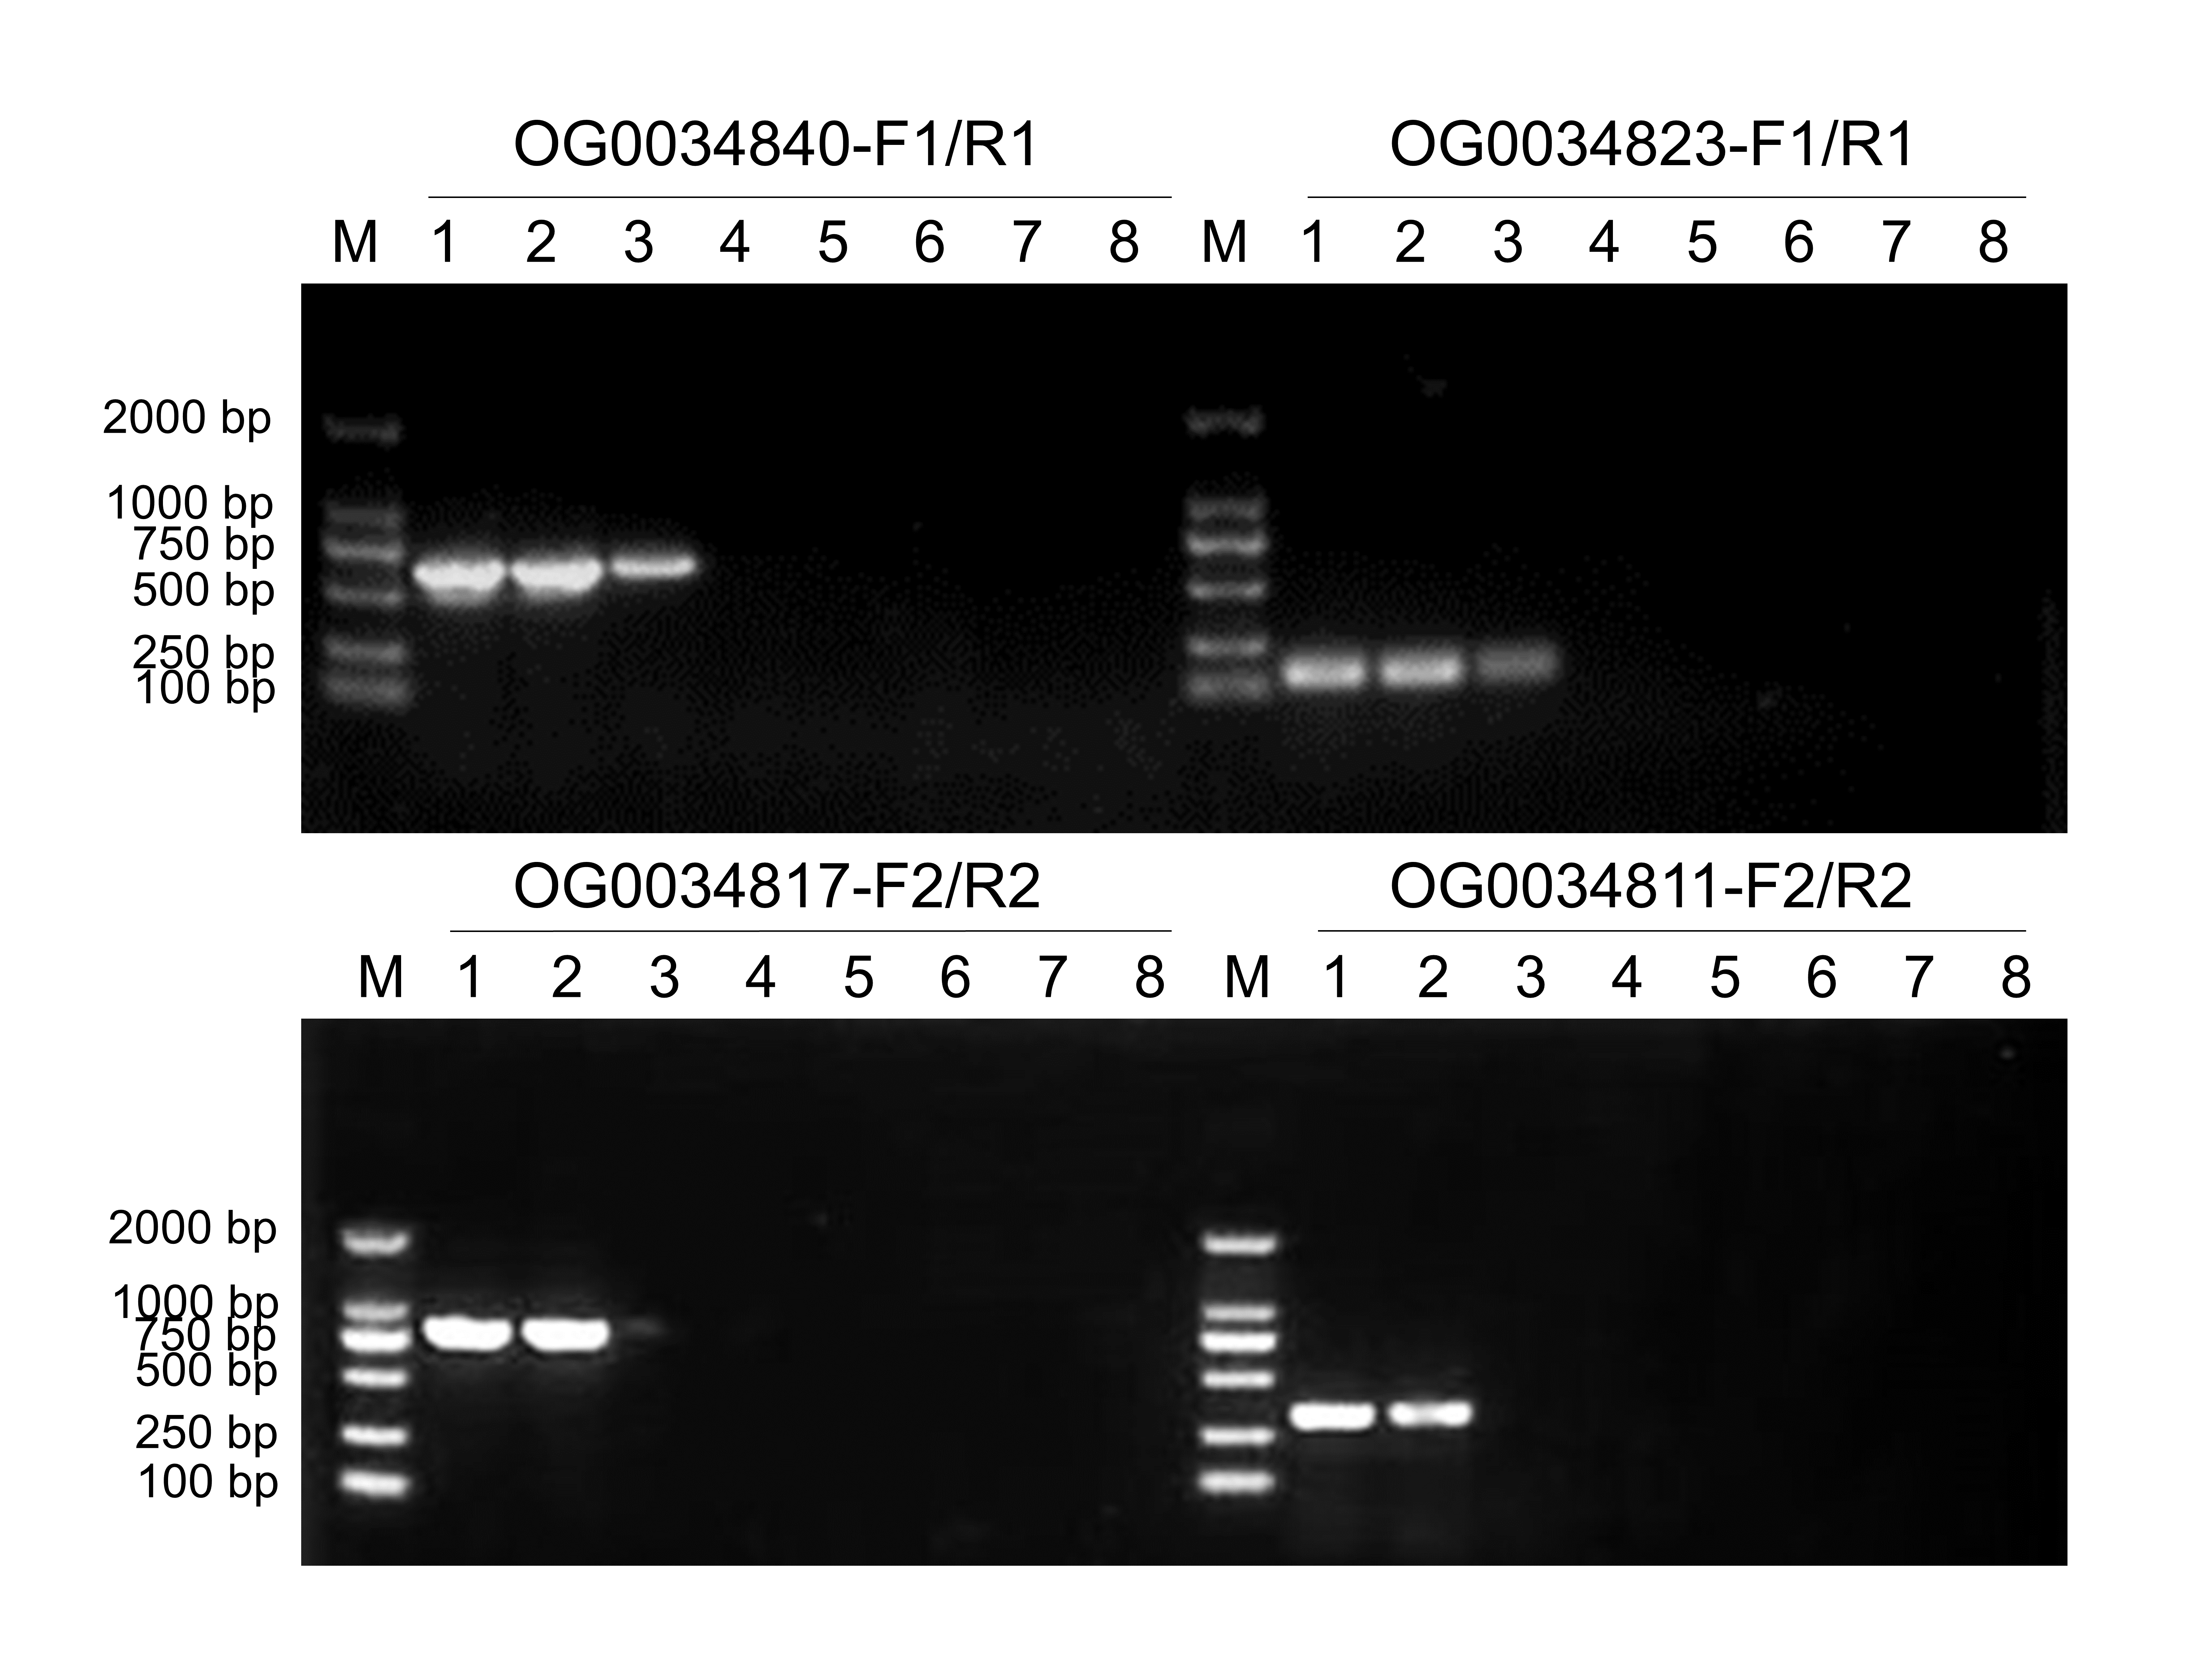

**Figure 3 Sensitivity testing of four pairs of specific primers.** M: 2, 000 bp DNA Ladder; 1-8 indicate different DNA concentrations: 1 ng/μL, 100 pg/μL, 10 pg/μL, 1 pg/μL, 100 fg/μL, 10 fg/μL, 1 fg/μL, and NTC (no-template control).

## 3.4 Evaluation of specific primers in infected plant tissues

To evaluate the efficacy of four pairs of specific primers in artificial infection of greater yam leaves, greater yam leaves that were inoculated with the *C. gloeosporioides* strain CgDa01 exhibited water-soaked lesions and turn dark brown as the infection progresses on the third day of cultivation. These lesions continued to expand and eventually merged into large necrotic tissue by the fifth day (Figure 4A). Conversely, the greater yam leaves in the control group exhibited no abnormal alterations. DNA from The CgDa01-inoculated leaves were extracted using the quick alkaline lysis extraction method [34], Four pairs of specific primers in this study were utilized to test the inoculated leaves. The results indicated that greater yam leaves inoculated with CgDa01 showed positive results as early as the first day of cultivation, whereas the control group's leaves consistently yielded negative results (Figure 4B).

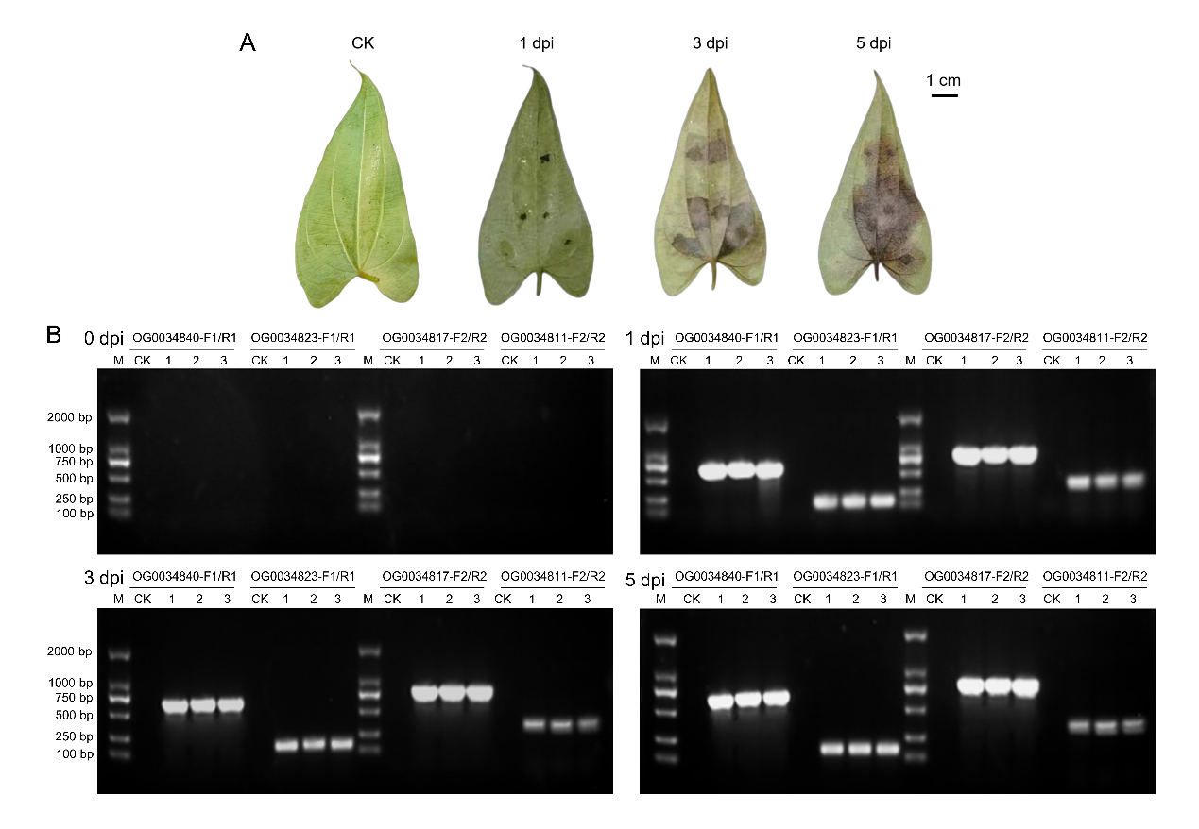

**Figure 4 Inoculation experiment and strips.** CK: control check; Dpi: Day post infection. **(A)** Leaf development after inoculation. **(B)** Results of extracted DNA assays of mixed pathogen-host plant samples from infested tissues on days 0, 1, 3, and 5 of inoculation, respectively. 1-3 are different sample inoculation groups. M: 2 000 bp DNA Ladder.

## 3.5 The Development of a Rapid Detection Kit for LF-RPA

We randomly selected Cg-OG0034840-F1/R1 for the following LF-RPA assay, and the corresponding probe CoProb was accordingly designed. A rapid detection kit was prepared by following the instructions of the TwistAmp nfo kit, using gradient-diluted template DNA from *C. gloeosporioides*. The results revealed that distinct bands at a concentration of 10 fg/μL and faint bands at 1 fg/μL, with all quality control lines being clearly discernible (Figure 5). The detection limit for the LF-RPA assay was 10 fg of genomic DNA, which is more sensitive than conventional PCR in the detection of *C. gloeosporioides* genomic DNA.



**Figure 5 Sensitivity testing of LF-RPA methods.** C: Control Band; T: Test Band.

# 4.Conclusion and Discussion

*Colletotrichum gloeosporioides* is responsible for causing anthracnose, a plant disease that is economically important and widely spread. Identifying this disease at its early stages in agricultural settings. Developing a rapid and user-friendly anthracnose diagnosis method is highly important and valuable for the cultivation of greater yam and other cash crops. We performed a genome-wide screening of sequences and designed amplification primers, which were then validated for specificity, sensitivity and real-world sample detection, and finally developed a practical RPA early detection kit.

OrthoFinder can accurately identify orthologous gene families from whole-genome data. Although our preliminary experiments suggested that certain genes were identified as conserved, however, further investigation revealed that the level of conservation was not as significant, only 9 out of 17 sets of sequences can be used to design molecular markers. There are two main possible explanations: One of the possible explanations is that OrthoFinder is primarily a tool for phylogenetic analysis across species. The algorithms may not be ideally suited for phenomena such as gene transposition, horizontal gene transfer, and gene loss[35]. But horizontal gene transfer has been widely observed in the *Colletotrichum* spp.[36], such as the genes *HGT1~HGT11*[37]. Another one is that the study contained four strains of *C. gloeosporioides* for the genomic baseline. Considering *C. gloeosporioides* is a complex species, with underexplored phylogenetic diversity among its subspecies and varieties[38], the representativeness of the gene pool could influence the efficacy and differentiation of our specific primers, and may not be uniformly applicable to all strains. In this study, the Jaccard coefficient of similarity, for the orthologous clusters of *C. gloeosporioides* was found to be only 0.656, also indicates a rich intraspecific diversity[11]. Additionally, each of the 17 orthologous clusters involved genes that comprised merely one to two copies. Notably, the four sets that were ultimately selected are all single-copy, being consistent with the conventional route of designing molecular markers based on single-copy genes[39]. Subsequently, expanding on the OrthoFinder-identified *C. gloeosporioides*-specific sequences through BLAST sequence alignment, we honed in on nine sequences for primer design. For future related studies, we advocate resequencing the target fungus or employing a more extensive sampling to enhance representativeness of the template. Notably, the OrthoFinder-identified *C. gloeosporioides*-specific genes might correlate with the pathogen's virulence or adaptability, as a basis warranting further functional and mechanistic exploration[40].

Achieving specificity is a formidable challenge in designing specific molecular markers for *C. gloeosporioides*[41]. Therefore, different strains and sources of *C. gloeosporioides*, closely related species within the *Colletotrichum* spp. and other pathogenic fungal species commonly found worldwide, which were used as materials for identification tests. They represent the three types of pathogens that need to be distinguished the most. Five of the primer pairs we designed for the nine groups of genes mentioned above did not show good species specificity, which was firstly caused by the low annealing temperature. In addition, it may be related to horizontal gene transfer and convergent evolution among pathogenic fungi[36]. The results of the study showed that the four primer pairs finally selected had species-level specificity and were able to specifically identify *C. gloeosporioides* from different sources.

Our results showed that the primers Cg-OG0034840-F1/R1 and Cg-OG0034823-F1/R1 exhibit exceptional sensitivity with a detection threshold of 0.1 ng/μL. These primers produced sharp, discrete bands at this concentration, may attributed to their compact sequence and reduced annealing temperature which yielded higher amplification efficiencies. In contrast, the detection limit of the other two primer pairs was only 1 ng/μL, due to their higher annealing temperature and easier formation of secondary structures in the Cg-OG0034811-F2 primer, but they can still be used as an alternative for specific detection.

Using the rapid diagnostic method established in this study to detect the leaves in the simulated inoculation experiment, it was found that the leaves inoculated with *C. gloeosporioides* strain CgDa01 were able to detect positive results on the first day of incubation, when the leaves did not yet have any obvious external symptoms, which was consistent with previous studies. Therefore, our approach has the capability to identify the disease-causing fungi in the asymptomatic parts, which can provide an effective means for the early diagnosis of yam anthracnose, that is conducive to the reduction of the spread of the disease and the improvement of the yield and quality of greater yam. Currently, methods for identifying *C. gloeosporioides* and its close relatives can be technically divided into two main categories: microscopic detection techniques based on the morphology of the organism and detection techniques based on PCR amplification of nucleic acid sequences. Because morphological identification is easily influenced by environmental factors, the latter is more used nowadays. In the host greater yam, Mithun Raj et al. previously used nested PCR to detect *C. gloeosporioides* limit of 200 fg/μL[42], and a recent study showed that real-time fluorescent quantitative PCR in other hosts such as *Arabidopsis thaliana* could increase the detection limit to 5 fg/μL[43]. Compared with the above PCR techniques, the RPA technique employed had a detection limit of merely 1 fg/μL in this study, which was significantly lower than that of previous reports. meanwhile, the RPA test kit developed here does not require complicated instruments and sites, and does not rely on the participation of specialists, so it can be easily disseminated in poor rural areas.

Ultimately, our study aimed to facilitate practical agricultural operations by offering direct and effective methods for detecting pathogens early and controlling diseases in a timely manner. Through the utilization of comprehensive whole-genome analysis, we have successfully obtained distinct molecular markers that precisely identify *C. gloeosporioides*. Additionally, we have achieved a significant milestone by introducing RPA technology for the detection of this pathogen on greater yam for the first time. Thus, we developed a novel and robust method for the rapid, transportable, and simple diagnosis of *C. gloeosporioides* in the field. This method also provided new research ideas for the detection and diagnosis of different fungal diseases. It enabled the early diagnosis of single or mixed infestation of the yam anthracnose pathogen, and established the groundwork for the prevention and control of these diseases.

# References

1. Wang, P.; Shan, N.; Ali, A.; Sun, J.; Luo, S.; Xiao, Y.; Wang, S.; Hu, R.; Huang, Y.; Zhou, Q.J.L. Comprehensive Evaluation of Functional Components, Biological Activities, and Minerals of Yam Species (*Dioscorea polystachya* and *D. alata*) from China. **2022**, *168*, 113964.

2. Lebot, V.; Lawac, F.; Legendre, L.J.J.o.F.C.; Analysis. The Greater Yam (*Dioscorea alata* L.): A Review of Its Phytochemical Content and Potential for Processed Products and Biofortification. **2023**, *115*, 104987.

3. Thomas, B. *Encyclopedia of Applied Plant Sciences*; Academic Press: 2016.

4. Ntui, V.O.; Uyoh, E.A.; Ita, E.E.; Markson, A.A.A.; Tripathi, J.N.; Okon, N.I.; Akpan, M.O.; Phillip, J.O.; Brisibe, E.A.; Ene‐Obong, E.O.E.J.M.P.P. Strategies to Combat the Problem of Yam Anthracnose Disease: Status and Prospects. **2021**, *22*, 1302-1314.

5. Agre, P.A.; Darkwa, K.; Olasanmi, B.; Kolade, O.; Mournet, P.; Bhattacharjee, R.; Lopez-Montes, A.; De Koeyer, D.; Adebola, P.; Kumar, L.; et al. Identification of QTLs Controlling Resistance to Anthracnose Disease in Water Yam (*Dioscorea alata*). *Genes (Basel)* **2022**, *13*, doi:10.3390/genes13020347.

6. Darkwa, K.; Olasanmi, B.; Asiedu, R.; Asfaw, A.; Léon, J. Review of empirical and emerging breeding methods and tools for yam (*Dioscorea* spp.) improvement: Status and prospects. *Plant Breeding* **2019**, *139*, 474-497, doi:10.1111/pbr.12783.

7. Dean, R.; Van Kan, J.A.; Pretorius, Z.A.; Hammond-Kosack, K.E.; Di Pietro, A.; Spanu, P.D.; Rudd, J.J.; Dickman, M.; Kahmann, R.; Ellis, J.; et al. The Top 10 Fungal Pathogens in Molecular Plant Pathology. *Mol Plant Pathol* **2012**, *13*, 414-430, doi:10.1111/j.1364-3703.2011.00783.x.

8. Wu, Z.G.; Jiang, W.; Nitin, M.; Bao, X.Q.; Chen, S.L.; Tao, Z.M.J.j.o.f.; analysis, d. Characterizing Diversity Based on Nutritional and Bioactive Compositions of Yam Germplasm (*Dioscorea* spp.) Commonly Cultivated in China. **2016**, *24*, 367-375.

9. Talhinhas, P. Hosts of *Colletotrichum*. *Mycosphere* **2023**, *14*, 158-261, doi:10.5943/mycosphere/14/si2/4.

10. Pornprapa, K.; Suriyasit, S.; Mongkutkarn, U.; Panisa, P.; Tanimnun, J. Cross-Resistance to Benzimidazole Group and Mancozeb Fungicides in *Colletotrichum* spp. Causing Anthracnose Disease. *Science & Technology Asia* **2022**, *27*, 400-408.

11. Liu, F.; Ma, Z.; Hou, L.; Diao, Y.; Wu, W.; Damm, U.; Song, S.; Cai, L.J.S.i.M. Updating Species Diversity of *Colletotrichum*, with a Phylogenomic Overview. **2022**, *101*, 1-56.

12. De Silva, D.D.; Crous, P.W.; Ades, P.K.; Hyde, K.D.; Taylor, P.W.J. Life Styles of *Colletotrichum* Species and Implications for Plant Biosecurity. *Fungal Biology Reviews* **2017**, *31*, 155-168, doi:10.1016/j.fbr.2017.05.001.

13. Sharma, G.; Pinnaka, A.K.; Shenoy, B.D.J.F.D. Resolving the *Colletotrichum siamense* Species Complex using ApMat Marker. **2015**, *71*, 247-264.

14. Gardes, M.; Bruns, T.D.J.M.e. ITS primers with Enhanced Specificity for Basidiomycetes‐application to the Identification of Mycorrhizae and Rusts. **1993**, *2*, 113-118.

15. Vieira, W.A.d.S.; Bezerra, P.A.; Silva, A.C.d.; Veloso, J.S.; Câmara, M.P.S.; Doyle, V.P. Optimal Markers for the Identification of *Colletotrichum* Species. *Molecular Phylogenetics and Evolution* **2020**, *143*, 106694, doi:<https://doi.org/10.1016/j.ympev.2019.106694>.

16. Toth, I.K.; Pritchard, L.; Birch, P.R.J.A.R.P. Comparative Genomics Reveals what Makes an Enterobacterial Plant Pathogen. **2006**, *44*, 305-336.

17. Gupta, R.S.; Patel, S.; Saini, N.; Chen, S.J.I.j.o.s.; microbiology, e. Robust Demarcation of 17 Distinct *Bacillus* Species Clades, Proposed as Novel *Bacillaceae* Genera, by Phylogenomics and Comparative Genomic Analyses: Description of *Robertmurraya kyonggiensis* sp. nov. and Proposal for an Emended Genus *Bacillus* Limiting It Only to the Members of the Subtilis and Cereus Clades of Species. **2020**, *70*, 5753-5798.

18. Miyauchi, S.; Kiss, E.; Kuo, A.; Drula, E.; Kohler, A.; Sánchez-García, M.; Morin, E.; Andreopoulos, B.; Barry, K.W.; Bonito, G.J.N.c. Large-Scale Genome Sequencing of Mycorrhizal Fungi Provides Insights into the Early Evolution of Symbiotic Traits. **2020**, *11*, 5125.

19. Fu, F.F.; Hao, Z.; Wang, P.; Lu, Y.; Xue, L.J.; Wei, G.; Tian, Y.; Hu, B.; Xu, H.; Shi, J.J.P. Genome Sequence and Comparative Analysis of *Colletotrichum gloeosporioides* Isolated from Liriodendron Leaves. **2020**, *110*, 1260-1269.

20. El Alaoui, M.A.; Msairi, S.; Kaissoumi, H.E.; Chliyeh, M.; Selmaoui, K.; Benkirane, R.; Ouazzani Touhami, A.; Douira, A. Phylogenetic Diversity of a Natural Population of *Colletotrichum* spp. Isolated from Different Substrates in Morocco. *PLANT CELL BIOTECHNOLOGY AND MOLECULAR BIOLOGY* **2021**, *22*, 84-94.

21. Emms, D.M.; Kelly, S.J.G.b. OrthoFinder: phylogenetic orthology inference for comparative genomics. **2019**, *20*, 1-14.

22. Zhang, M.; Xu, W.; Mei, H.; Song, G.; Ge, N.; Tao, Y.; Liu, W.; Liang, G.J.A.o.M. Comparative Genomics Predict Specific Genes in Potential Mucorales Identification. **2023**, *205*, 320.

23. Yang, J.; Duan, K.; Liu, Y.; Song, L.; Gao, Q.H.J.J.o.P. Method to Detect and Quantify Colonization of Anthracnose Causal Agent *Colletotrichum gloeosporioides* Species Complex in Strawberry by Real‐time PCR. **2022**, *170*, 326-336.

24. Syafitri, L.M.; Wibowo, A.; Widiastuti, A.; Subandiyah, S.; Harper, S.J.B.J.o.B.D. Molecular Identification of *Colletotrichum gloeosporioides* Causing Anthracnose on Shallot in Bantul, Yogyakarta, Indonesia. **2023**, *24*.

25. Li, J.; Macdonald, J.; Von Stetten, F.J.A. A Comprehensive Summary of a Decade Development of the Recombinase Polymerase Amplification. **2019**, *144*, 31-67.

26. Wang, Y.; Xu, W.T.; Lu, R.S.; Chen, M.; Liu, J.; Sun, X.Q.; Zhang, Y.M.J.P.D. Genome Sequence Resource for *Colletotrichum gloeosporioides*, an Important Pathogenic Fungus Causing Anthracnose of *Dioscorea alata*. **2023**, *107*, 893-895.

27. Nguyen, H.D.; Sultana, T.; Kesanakurti, P.; Hambleton, S.J.I.f. Genome Sequencing and Comparison of Five *Tilletia* Species to Identify Candidate Genes for the Detection of Regulated Species Infecting Wheat. **2019**, *10*, 1-17.

28. Hall, T.; Biosciences, I.; Carlsbad, C.J.G.B.B. BioEdit: an Important Software for Molecular Biology. **2011**, *2*, 60-61.

29. Johnson, M.; Zaretskaya, I.; Raytselis, Y.; Merezhuk, Y.; McGinnis, S.; Madden, T.L.J.N.a.r. NCBI BLAST: a Better Web Interface. **2008**, *36*, W5-W9.

30. Aamir, S. A Rapid and Efficient Method of fungal Genomic DNA Extraction, Suitable for PCR Based Molecular Methods. *Plant Pathology & Quarantine* **2015**, *5*, 74-81, doi:10.5943/ppq/5/2/6.

31. Lalitha, S.J.B.S.; Scient, I.R.T.C.S.J.f. Primer Premier 5. **2000**, *1*, 270-272.

32. Huang, L.; Li, Q.C.; Zhang, Y.; Li, D.W.; Ye, J.R.J.P.D. *Colletotrichum gloeosporioides* Sensu Stricto is a Pathogen of Leaf Anthracnose on Evergreen Spindle Tree (*Euonymus japonicus*). **2016**, *100*, 672-678.

33. Litholdo Junior, C.G.; Gomes, E.V.; Lobo Junior, M.; Nasser, L.C.; Petrofeza, S. Genetic Diversity and Mycelial Compatibility Groups of the Plant-Pathogenic Fungus *Sclerotinia sclerotiorum* in Brazil. *Genet Mol Res* **2011**, *10*, 868-877, doi:10.4238/vol10-2gmr937.

34. Chomczynski, P.; Rymaszewski, M. Alkaline Polyethylene Glycol-Based Method for Direct PCR from Bacteria, Eukaryotic Tissue Samples, and Whole Blood. *BioTechniques* **2006**, *40*, 454, 456, 458, doi:10.2144/000112149.

35. Yadav, A.; Fernández-Baca, D.; Cannon, S.B.J.b. A Sequence-Pair-Classification-Based Method for Detecting and Correcting Under-Clustered Gene Families. **2020**, 2020.2002. 2022.942557.

36. Qiu, H.; Cai, G.; Luo, J.; Bhattacharya, D.; Zhang, N. Extensive Horizontal Gene Transfers between Plant Pathogenic Fungi. *BMC Biol* **2016**, *14*, 41, doi:10.1186/s12915-016-0264-3.

37. Jaramillo, V.D.; Sukno, S.A.; Thon, M.R. Identification of Horizontally Transferred Genes in the Genus *Colletotrichum* Reveals a Steady Tempo of Bacterial to Fungal Gene Transfer. *BMC Genomics* **2015**, *16*, 2, doi:10.1186/1471-2164-16-2.

38. Weir, B.; Johnston, P.; Damm, U.J.S.i.m. The *Colletotrichum gloeosporioides* Species Complex. **2012**, *73*, 115-180.

39. Kim, D.; Gilchrist, C.L.; Chun, J.; Steinegger, M.J.N.A.R. UFCG: Database of Universal Fungal Core Genes and Pipeline for Genome-Wide Phylogenetic Analysis of Fungi. **2023**, *51*, D777-D784.

40. Hsieh, D.K.; Chuang, S.C.; Chen, C.Y.; Chao, Y.T.; Lu, M.Y.J.; Lee, M.H.; Shih, M.C.J.F.i.M. Comparative Genomics of Three *Colletotrichum scovillei* Strains and Genetic Analysis Revealed Genes Involved in Fungal Growth and Virulence on Chili Pepper. **2022**, *13*, 818291.

41. Al-Ahmad, A.; Mosca, S.; Li Destri Nicosia, M.G.; Cacciola, S.O.; Schena, L. Molecular Analysis of *Colletotrichum* Species in the Carposphere and Phyllosphere of Olive. *PLoS ONE* **2014**, *9*, doi:10.1371/journal.pone.0114031.

42. Raj, M.; Jeeva, M.; Hegde, V.; Vidyadharan, P.; Archana, P.; Senthil alias Sankar, M.; Nath, S.V. Polymerase Chain Reaction Assay for Rapid, Sensitive Detection, and Identification of *Colletotrichum gloeosporioides* Causing Greater Yam Anthracnose. *Mol Biotechnol* **2012**, *52*, 277-284, doi:10.1007/s12033-012-9496-9.

43. Wan, M.; Yang, L.; Zhang, S.; Gao, J.; Jiang, L.; Luo, L. Real-time PCR for Detection and Quantification of *C. gloeosporioides* s.l. Growth in *Stylosanthes* and *Arabidopsis*. *Crop Protection* **2022**, *159*, 106021, doi:<https://doi.org/10.1016/j.cropro.2022.106021>.

# Acknowledgements

We thank Prof. Dou Daolong and Associate Researcher Zhao Yuqiang for the gift of strains.